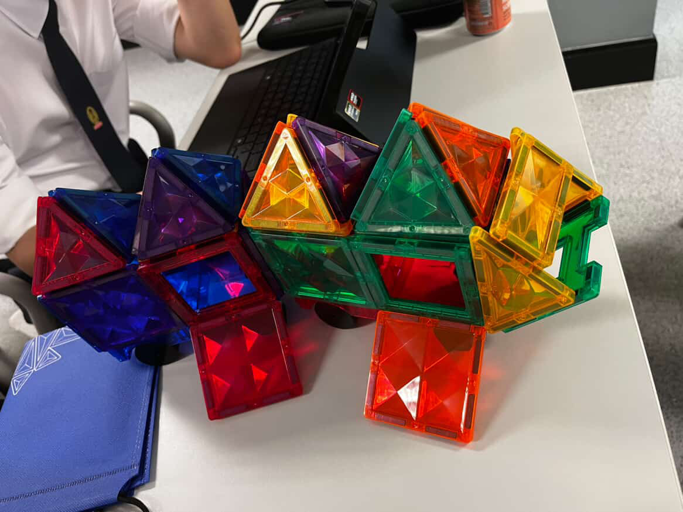

In our dystopian world, the planet is slowly collapsing due to the immense amounts of non-renewable energy sources being used, causing extreme weather. With a nuclear power plant exploding in the nearby rural area, lots of people either lost their lives or were severely injured. Resources are scarce, and technology is not advanced enough; thus, we took matters into our own hands and created a safe and environmentally friendly vehicle accessible to all.

For this design, our group prioritized accessibility, inclusivity, and efficiency for all. This design demonstrates integration of resources to prioritize sustainability whilst also saving space, with a more modern architectural design.

Noticeably, this design includes ramps as an entrance. These ramps are able to be folded up into walls, making it easy for those with disabilities to enter the vehicle (such as those in wheelchairs). As it folds up to complete the walls, it saves space whilst also being aesthetically and visually appealing whilst also saving space. The walls are also made from bulletproof steel, as well as bulletproof glass to keep the vehicle safe yet making sure those inside can look out.

Other than adding dimension to the design, the roof is designed in a very specific way – a pyramid-like structure at the top of every procession. By positioning the triangular tiles at an angle, the design mimics the way solar panels are typically installed to maximize energy absorption, making the design sustainable and also minimizing the use of non-renewable energy to sustain our planet.

Consequently, this design has three main purposes: sustainability, innovation, and efficiency for all. Whilst also being visually appealing, this design incorporates many different structures that are not only functional but also environmentally and socially responsible. In a world where technology is advancing, it is important to use it right to preserve our one and only home.